Q1. Explain Constructor in java programming?

Ans:

A constructor is a special member function of a class it is used to initialize the member data of a class and also done memory allocation inside the heap

Rules of Constructors

1. A class name and constructor name must be same.
2. Constructor does not have any return type even void
3. Constructor is automatically called when object is created.

**Types of constructors:**

* Default Constructor(Parameter less constructor)
* Parameterized constructor(with parameters)

If we don’t write any constructor in our program then compiler automatically add default constructor

If we write any type of constructor then compiler does not add any constructor in our program

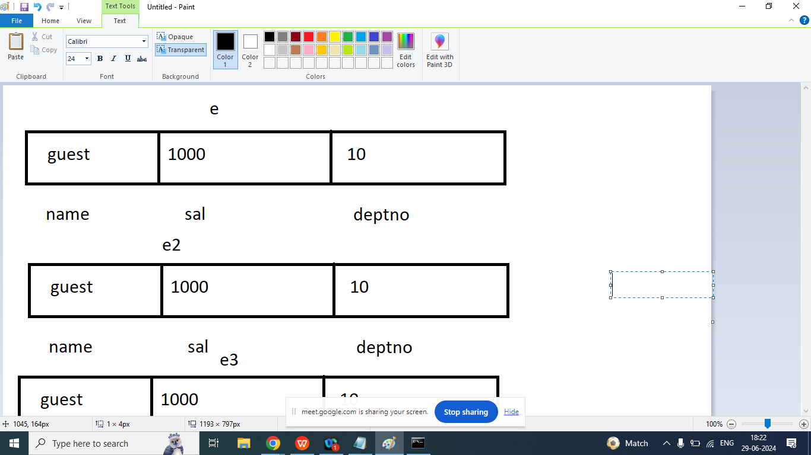

Syntax:

class Emp{

String name;

float sal;

int deptno;

public Emp(){

name=”guest”;

Sal=1000;

deptno=10;

}

}

Example: Default Constructor

class Emp{

String name;

float sal;

int deptno;

public Emp(){

System.out.println("Default constructor is called");

name="guest";

sal=1000;

deptno=10;

}

public void showData(){

System.out.println("Name : "+name);

System.out.println("Salary : "+sal);

System.out.println("Deptno : "+deptno);

}

public static void main(String args[]){

Emp e=new Emp();

e.showData();

Emp e1=new Emp();

e.showData();

Emp e2=new Emp();

e2.showData();

}

}

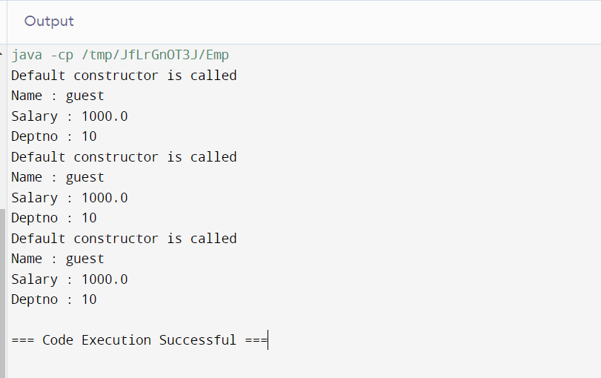

Example Parameterized Constructor

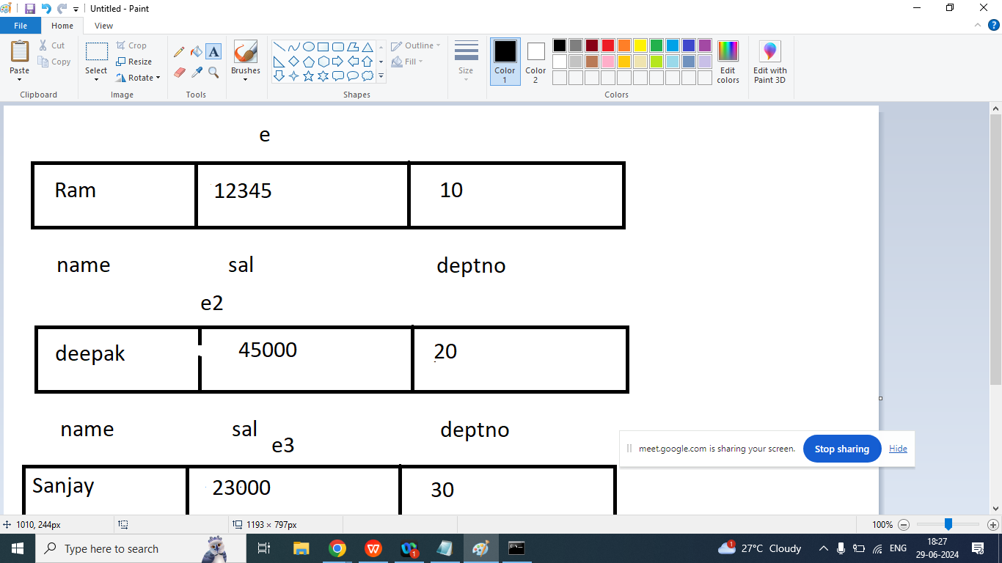

class Emp{

String name;

float sal;

int deptno;

public Emp(){

System.out.println("Default constructor is called");

name="guest";

sal=1000;

deptno=10;

}

public Emp(String n,float s, int d){

System.out.println("Parameterized constructor is called");

name=n;

sal=s;

deptno=d;

}

public void showData(){

System.out.println("Name : "+name);

System.out.println("Salary : "+sal);

System.out.println("Deptno : "+deptno);

}

public static void main(String args[]){

Emp e=new Emp("Ram",12345,10);

e.showData();

Emp e1=new Emp("Deepak",45000,20);

e1.showData();

Emp e2=new Emp("Sanjay",23000,30);

e2.showData();

}

}

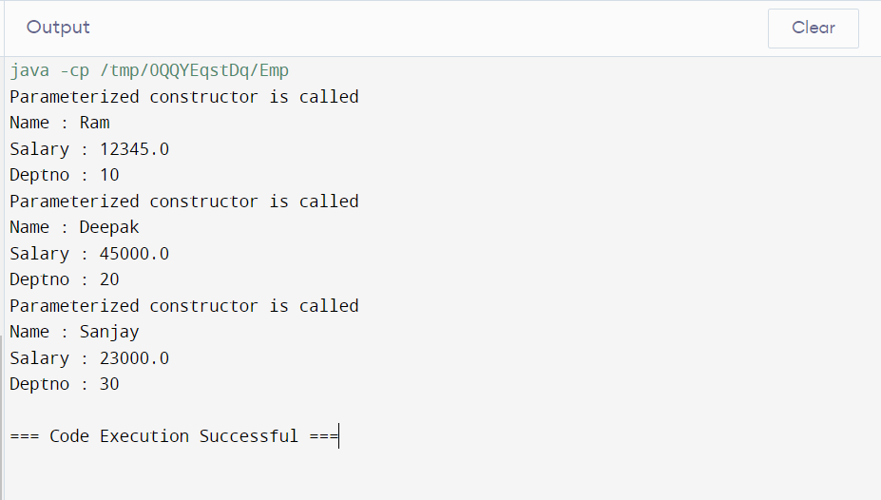

class Emp{

String name;

float sal;

int deptno;

public Emp(){

System.out.println("Default constructor is called");

name="guest";

sal=1000;

deptno=10;

}

public void showData(){

System.out.println("Name : "+name);

System.out.println("Salary : "+sal);

System.out.println("Deptno : "+deptno);

}

public Emp(String n,float s, int d){

System.out.println("Parameterized constructor is called");

name=n;

sal=s;

deptno=d;

}

public static void main(String args[]){

Emp e=new Emp("Ram",12345,10);

e.showData();

Emp e1=new Emp("Deepak",45000,20);

e1.showData();

Emp e2=new Emp("Sanjay",23000,30);

e2.showData();

}

}

